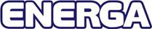
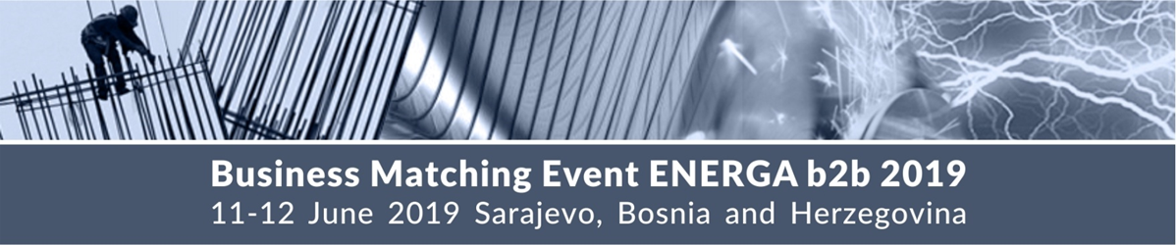
Business Matching Event ENERGA b2b 2019

within the 9th international energy, mining, environment protection and
related industry fair ENERGA 2019

Sarajevo Economic Region Development Agency SERDA and Enterprise Europe Network in Bosnia and Herzegovina with support of many international organizations and business support agencies from European Union and the region are organizing Business Matching Event at ENERGA 2019, the 9th international energy, mining, environment protection and related industry fair (11 – 13.06.2019). For more info visit the fair website: http://energa.ba/

The Business Matching Event ENERGA b2b 2019 will be held on 11th and 12th of June 2019 at Skenderija Center, Sarajevo and will provide additional support to the companies in finding international partners at the fair. The participants are offered to choose their potential partners according to their own needs and interests and to discuss possible cooperation.
In recent years, the ENERGA exhibition and conference, with their programs and participants’ structure, have been reaffirmed as a successful and attractive business event and have taken their place among the most significant energy-related happenings in the region. The ENERGA exhibition is where distinguished domestic and international companies meet and where current trends, as well as various research and production achievements in production and distribution of electrical energy, fossil fuels, renewable energy sources, energy efficiency, related industry (metal, machinery, construction and engineering) and different forms of business cooperation between domestic and international companies are presented.

Aware of the fact that innovation and technological advancement form the basis for further development of the sector, for the 9th edition of ENERGA we announce a greater presence of students, young experts and start-up companies that will be able to present their businesses through a specially designed program, sessions and designed fairground ideas and projects.

Thematic focus of the Business Matching Event:
- Energy
- Electric-Electronics
- Mining
- Environment
- Metal and Machinery
- Automotive Industry
- Construction and Construction Materials
- Engineering, Design and Consulting
- Women Entrepreneurship

Why to participate:
The participation in the business matchmaking event is free of charge and includes:
- Personalized meeting schedule (prearranged 25-minute meetings)
- Information package provided on the day of the event
- Business assistance of Enterprise Europe Network partners before, during and after the event
Official Language Spoken: English
Venue:
Skenderija Center, Terezija bb, Sarajevo, Bosnia and Herzegovina

Agenda 11th June 2019:
11:00 – 12:30 Official Opening Ceremony of ENERGA 2019 Fair
12:30 – 13:00 Registration of the participants of ENERGA b2b 2019 event and
handover of meeting schedules
13:00 – 16:00 Bilateral Business Meetings

Agenda 12th June 2019:
11:00 – 13:00 Bilateral Business Meetings

Deadlines:
- June 10th 2019: Online registration of participants
(inserting the cooperation profile on event web page)
- June 3-10th 2019: Choosing interesting profiles and booking B2B meetings on event
web page
- June 11-12th 2019: Business Matching Event ENERGA b2b 2019

Sign up now for this FREE business matching event and book your meetings at: http://energa2019.talkb2b.net
More information: Sarajevo Economic Region Development Agency SERDA/Enterprise Europe Network, Aida Džamalija Duran, tel: +387 33 652 935, e-mail: aida@serda.ba

